NOS-120 Chapter 8

Log into NDG and workstation virtual Classroom Machine to complete this quiz.

**Before you begin this quiz run the following command five times: sleep 99999 &**

1. Type the command that will display the list of jobs that bash is tracking for a particular session.

Insert Screenshot Below:

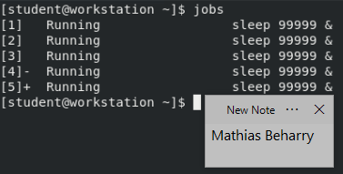

1. Type the command that will bring job #2 for the foreground. Once complete use **ctrl+z** to suspend that job.

Insert Screenshot Below:

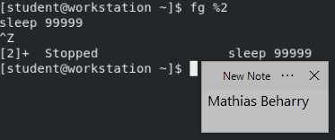

1. Type the command with the appropriate options that will display all processes including processes without a controlling terminal. Make sure to show the sleep process’s in your screen shot.

Insert Screenshot Below:

**Using command: ps aux**

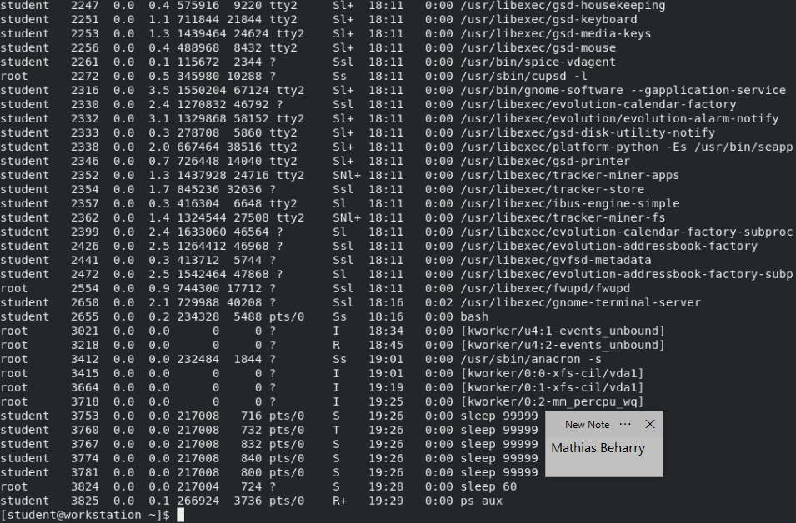

**Using command: ps aux | grep sleep**

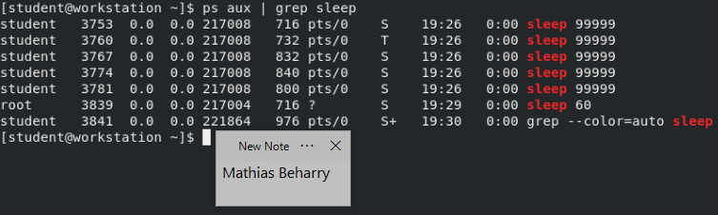

1. Type the command with the appropriate option that will send a signal to one of the sleep pid’s to cause abrupt program termination that cannot be blocked, ignored, or handled.

Insert Screenshot Below:

